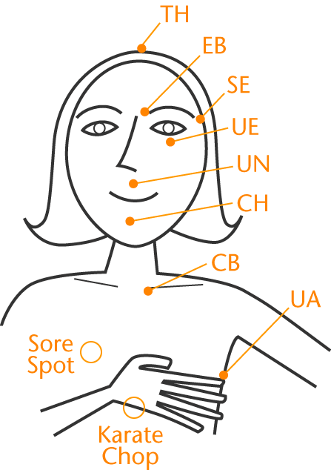

# EFT/Tapping instructions

1. Select a problem, as specific as possible, about which you would like some relief. Rate the distress level of that problem from 0-10 (0=none, 10=worst).
2. While tapping on the karate chop point, or rubbing the sore spot, say your set up phrase, “Even though I have _____ (this problem), I deeply and completely accept myself.” Repeat the phrase three times while tapping the karate chop point.
3. Use the reminder phrase “(this problem)” while tapping 5-7 times (approximate) on each of the tapping sequence points, starting at the top of the head. It is not necessary to continue with the karate chop point and it is not necessary to continue repeating three times, you can just say the reminder phrase once for each tapping point. But you can use it as many times as you like, there is no right or wrong in EFT/tapping! Take a deep breathe at the end of a cycle, let it go.
4. Continue cycling through the tapping points until you feel relief or until you feel a shift or a change in your distress. You will know when you know. Check in with your distress level again, 0-10. If it is not at a zero and you would like to continue to tap on the problem you can say, “this remaining (problem)” as your reminder phrase. Repeat until you feel relief, or until you reach a distress level of zero. Sometimes it takes just a few minutes to find relief from the problem, sometimes it takes longer. Just like anything new we learn, the more you practice the better you will get at it and the quicker you will likely see results!